EXPERIMENT 3: DDL COMMANDS

SQL> CREATE TABLE LANGUAGE(language_id INT PRIMARY KEY, name VARCHAR(20) );

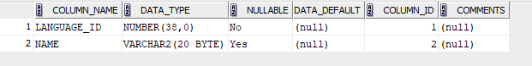

SQL> CREATE TABLE PUBLISHER(publisher_id INT PRIMARY KEY, name VARCHAR(20), address VARCHAR(20));

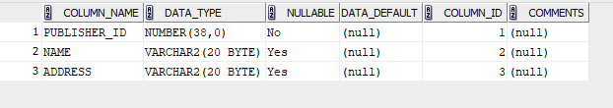

SQL> CREATE TABLE MEMBER(member_id INT PRIMARY KEY,

name VARCHAR(20),

branch_code VARCHAR(20),

roll_no INT,

phone_number INT,

email_id VARCHAR(20),

date_of_join DATE,

status VARCHAR(20));

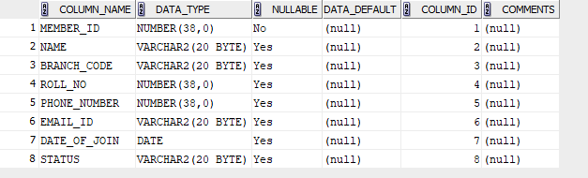

SQL> CREATE TABLE AUTHOR(author_id INT PRIMARY KEY, name VARCHAR(20), email_id VARCHAR(20), phone_number INT, status VARCHAR (20) );

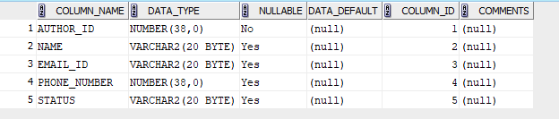

SQL> CREATE TABLE BOOK(book_id INT PRIMARY KEY,

title VARCHAR(20),

language_id INT,

MRP FLOAT,

publisher_id INT,

published_date DATE,

volume INT,

status VARCHAR(20),

FOREIGN KEY(language_id) REFERENCES LANGUAGE,

FOREIGN KEY(publisher_id) REFERENCES PUBLISHER);

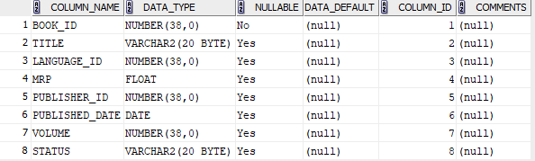

SQL> CREATE TABLE BOOK_AUTHOR(book_id INT,

author_id INT,

PRIMARY KEY(book_id, author_id),

FOREIGN KEY(book_id) REFERENCES BOOK,

FOREIGN KEY(author_id) REFERENCES AUTHOR);

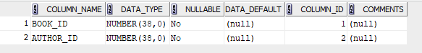

SQL> CREATE TABLE BOOK_ISSUE(issue_id INT PRIMARY KEY,

date_of_issue DATE,

book_id INT,

member_id INT,

expected_date_of_join DATE,

status VARCHAR(20),

FOREIGN KEY(book_id) REFERENCES BOOK,

FOREIGN KEY(member_id) REFERENCES MEMBER);

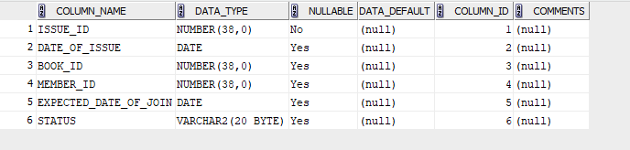

SQL> CREATE TABLE BOOK_RETURN(issue_id INT PRIMARY KEY,

actual_date_of_return DATE,

late_days INT,

late_fee FLOAT,

FOREIGN KEY(issue_id) REFERENCES BOOK_ISSUE);

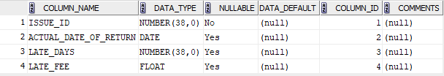

SQL> CREATE TABLE LATE_FEE_RULE(from_days INT,

to_days INT,

amount FLOAT,

PRIMARY KEY(from_days, to_days, amount));

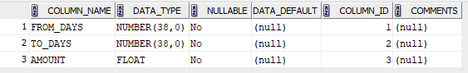

SQL> ALTER TABLE BOOK ADD no_of_times_issued INT;

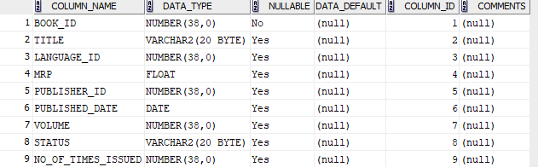

SQL> ALTER TABLE MEMBER MODIFY branch_code INT;

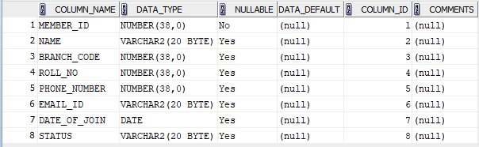

SQL> INSERT INTO AUTHOR VALUES(1, 'JIBIN', 'j@gmail.com', 6262626262, 'Inactive');

INSERT INTO AUTHOR VALUES(2, 'KEVIN', 'k@gmail.com', 9292696692, 'Active');

INSERT INTO AUTHOR VALUES(3, 'MANU', 'm@gmail.com', 9288628262, 'Inactive');

SELECT * FROM AUTHOR;

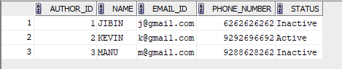

SQL > ALTER TABLE PUBLISHER MODIFY address VARCHAR(50);

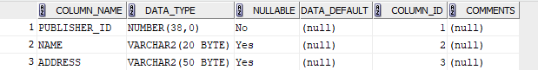

SQL > ALTER TABLE MEMBER MODIFY email_id VARCHAR(50);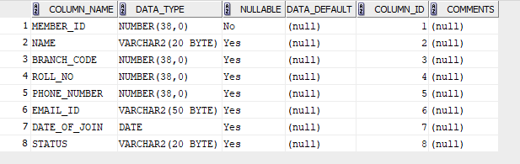

SQL > INSERT INTO PUBLISHER VALUES (1, 'TONY', 'Stark Towers, New York');

INSERT INTO PUBLISHER VALUES (2, 'PETER', 'Tea Nagar, Chennai');

INSERT INTO PUBLISHER VALUES (3, 'MJ', 'Cinema Nagar, Kolkata');

SELECT * FROM PUBLISHER;

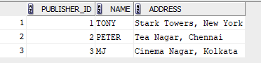

SQL > INSERT INTO LANGUAGE VALUES (1, 'ENGLISH');

INSERT INTO LANGUAGE VALUES (2, 'HINDI');

INSERT INTO LANGUAGE VALUES (3, 'MALAYALAM');

SELECT * FROM LANGUAGE;

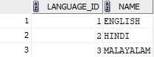

SQL > INSERT INTO MEMBER VALUES(1, 'JOHN', 198, 11, 8525852585, 'john@gmail.com', '02-09-24', 'Inactive');

INSERT INTO MEMBER VALUES(2, 'JIZZ', 198, 12, 9525456585, 'jizz@gmail.com', '02-09-24', 'Inactive');

INSERT INTO MEMBER VALUES(3, 'JINO', 198, 13, 6521236585, 'jino@gmail.com', '02-09-24', 'Active');

SELECT * FROM MEMBER;

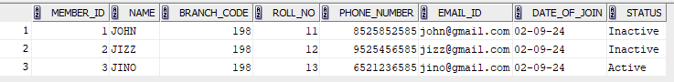

SQL > INSERT INTO BOOK VALUES(1, 'Raj Simha', 1, 82.2, 1, '11-01-1999', 1, 'Available', 10);

INSERT INTO BOOK VALUES(2, 'Raj Bhavan', 2, 82.2 , 2, '11-01-1999', 2, 'Available', 12);

INSERT INTO BOOK VALUES(3, 'Raj Kumar', 3, 82.2 , 3, '19-02-1999', 3, 'Unavailable', 14);

SELECT * FROM BOOK;



SQL > INSERT INTO BOOK_AUTHOR VALUES(1, 1);

INSERT INTO BOOK_AUTHOR VALUES(2, 2);

INSERT INTO BOOK_AUTHOR VALUES(3, 3);

SELECT * FROM BOOK_AUTHOR;

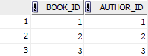

SQL > INSERT INTO BOOK_ISSUE VALUES(1, '02-02-24', 1, 1, '06-02-24', 'No dues');

INSERT INTO BOOK_ISSUE VALUES(2, '04-02-24', 2, 2, '08-02-24', 'dues');

INSERT INTO BOOK_ISSUE VALUES(3, '06-02-24', 3, 3, '10-02-24', 'dues');

SELECT * FROM BOOK_ISSUE;

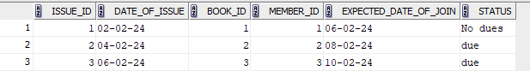

SQL > INSERT INTO BOOK_RETURN VALUES(1, '06-02-24', 0, 0);

INSERT INTO BOOK_RETURN VALUES(2, '08-02-24', 1, 10);

INSERT INTO BOOK_RETURN VALUES(3, '10-02-24', 2, 20);

SELECT * FROM BOOK_RETURN;

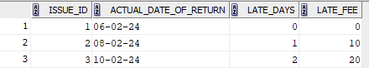

SQL > INSERT INTO LATE_FEE_RULE VALUES (0, 7, 10);

INSERT INTO LATE_FEE_RULE VALUES(7, 30, 100);

INSERT INTO LATE_FEE_RULE VALUES(30, 45, 150);

SELECT * FROM LATE_FEE_RULE;

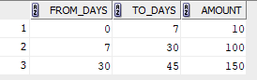

SQL > ALTER TABLE BOOK DROP COLUMN Publisher_id;

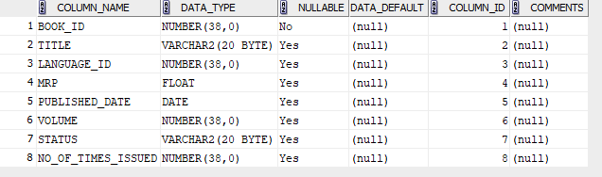

SQL > TRUNCATE TABLE PUBLISHER;

SELECT * FROM PUBLISHER;



SQL > DROP TABLE BOOK_AUTHOR;

DROP TABLE AUTHOR;

SELECT * FROM AUTHOR;

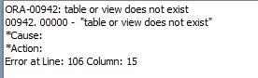

SQL > ALTER TABLE LATE_FEE_RULE RENAME TO FINE_TABLE;

SELECT * FROM FINE_TABLE;

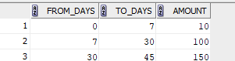

SQL > COMMIT;

